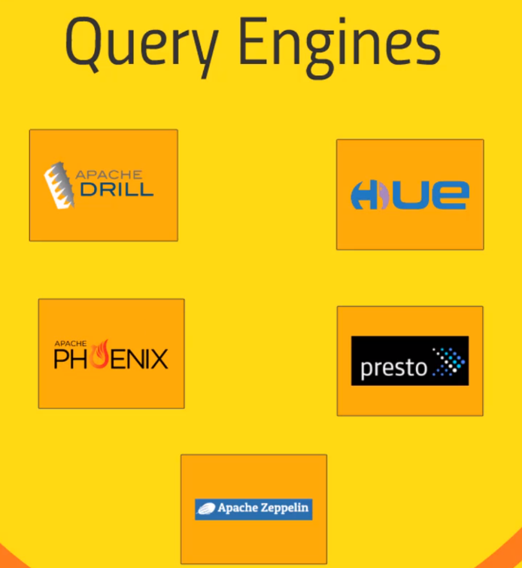Query Engines that sits on top of the Technologies.

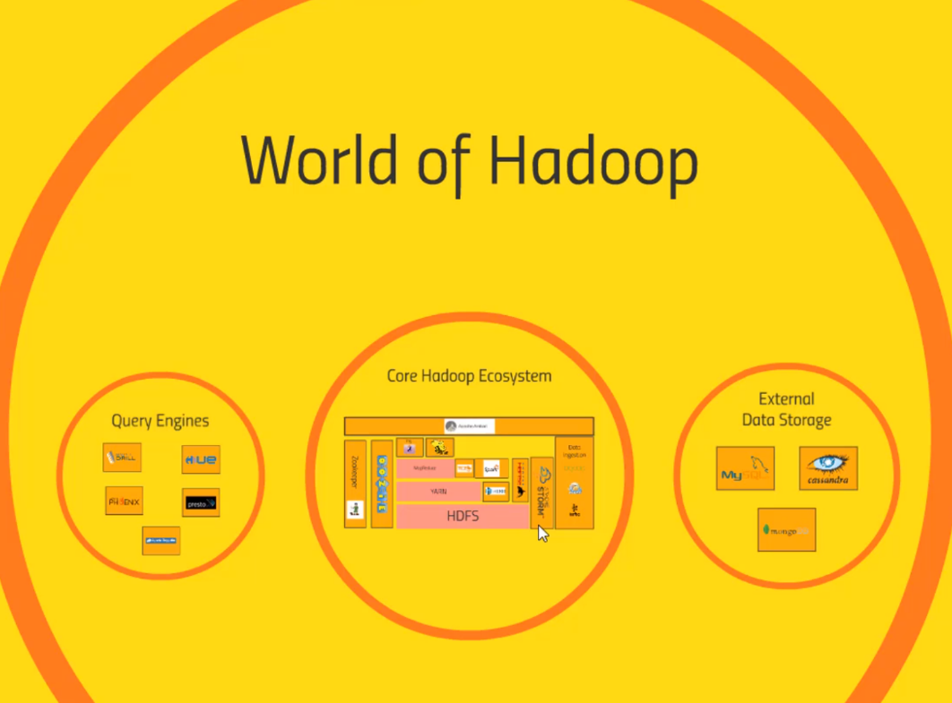Presto a lot like Drill. It is made by facebook can talk to Cassandra while drill cannot., Drill can talk to MongoDB

Apache Drill -> SQL for noSQL

A SQL Query Engine for a variety of non-relational databases and data files

* Hive, MongoDB, HBase
* Even flat JSON or Parquet files on HDFS, S3, Azure, Google Cloud, Local file System
* Based on Google’s Dremel

Its real SQL- has ODBC/JDBC driver so other tools can connect to it just like any relational database. Such as Tableau.

Apache Phoenix – sit on top of HBase.

Drill – let u execute SQL queries.

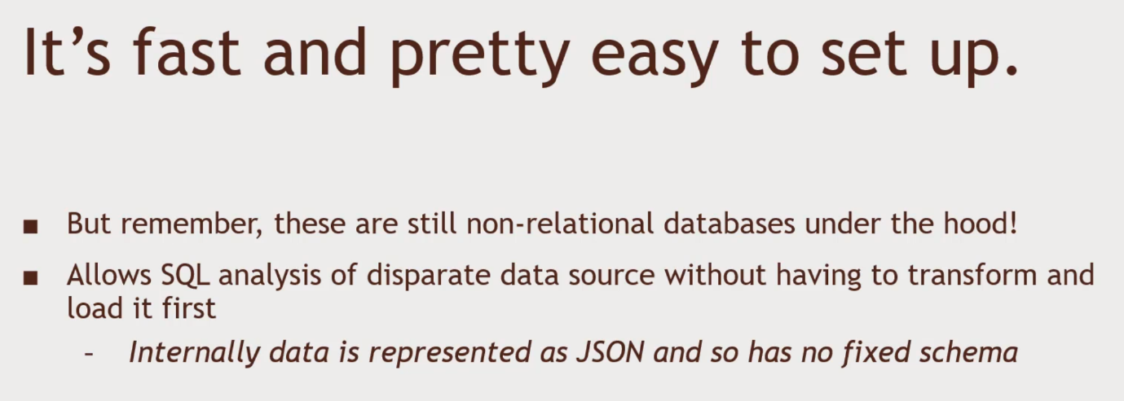SQL FOR YOUR ENTIRE ECOSYSTEM.

Exercise.

U can join across different database technologies.

Import data into Hive and MongoDB. Setup Drill on top of both and do some queries.

Setup Hortonworks Sandbox set up and running.

Get data sources, MongoDB, Hive